Docker Troubleshooting and Error Resolution
  - Why errors occur and how to diagnose and fix them
Emadfar007 | CSA1020 Software Engineering | Updated 29 October 2026

Aim
To provide practical fixes for the Docker problems encountered in the experiments. Each entry identifies the symptom, explains why it occurs, shows how to confirm the diagnosis, gives ordered repair steps and states how to verify the result. Confirmed causes are separated from likely explanations and unproven deeper causes.
The current experiments run in the private GitHub Codespaces Docker lab. Docker Desktop was intentionally uninstalled after migration and preservation checks. Windows installation and boot repairs below describe the earlier local setup; a missing local Docker executable now does not mean that the browser lab is broken.

Tools Required
Use the Codespaces browser terminal, Docker CLI, existing project files and saved logs. WSL tools and an administrator PowerShell window apply only to the historical Windows Desktop cases. Kubernetes, Jenkins and GitHub Actions tools are used only where the failing component is a Docker workload or deployment dependency.
Open the existing Codespaces lab
Current browser lab instructions
Where the failure occurs | Relevant entries
Windows installer WSL hypervisor or shortcut | D01 to D04
Docker recovery health checks or stopped daemon | D05 D06 D08
Disk memory or maintenance verification | D09 D10
Kubernetes probes or cloud startup helpers | D07 D11 D12
Database verifier permissions | D13
Dashboard startup or ephemeral storage | D14 D15
Hosting quota and Docker delivery pipeline | D16 to D20

Algorithm

Start by identifying the failing component
- Open the terminal on the machine that actually runs Docker. For this lab, that is the existing Codespace, not the laptop from which Desktop was removed.
- Check Docker Client and Server information, container state and health logs before changing configuration.
- Match the exact error to a case below. An HTTP 403, a Kubernetes eviction and a stopped Docker daemon require different repairs.
- Preserve persistent data and the previous working runtime before changing a container. Use the narrow repair and then verify the actual response.
Codespaces Bash read-only first checks
docker version
docker info
docker ps -a
bash browser-lab/bin/lab status
Expected interpretation: Client-only output does not establish a running daemon. Running does not establish Ready or healthy. A private app address also requires GitHub sign-in and its matching profile. Windows PowerShell command blocks are explicitly labelled; use curl.exe there if testing HTTP, because curl can be a PowerShell alias.
Recorded fixes were verified on 26 to 28 October 2026. The command blocks are instructions for diagnosis or reproduction, not a claim that the repairs were rerun while revising this guide. Starting an individual cloud profile stops other profiles while retaining their data.

Docker installation and Windows dependencies

D01 Docker installer rejects the selected backend
Component Windows Docker installation
Error or symptom The installer rejected --backend=docker-vmm during the per-user installation.
Why the error occurs The value docker-vmm was not supported by that Windows installation route. An installer-option failure occurs before the Docker daemon can run; rebuilding an application image cannot fix it.
Cause confidence Confirmed from the retained installer checkpoint.
How to diagnose it Read the installer error and check the supported options for the installer version. Identify whether the failure is installation or an already-installed daemon startup problem.
How to fix it
1. For the historical local setup, omit the rejected backend value and use the supported per-user installation with the normal WSL backend.
2. Finish the WSL and virtualization checks in D02 and D03 before expecting the Linux engine to start.
3. The current browser lab does not require a new local Docker Desktop installation.
Historical Windows PowerShell installer command
& ".\Docker Desktop Installer.exe" install --user --quiet
Verify the fix The recorded install --user --quiet path succeeded. Docker Desktop 4.96.3 and CLI 29.9.2 subsequently ran. For an installed local setup, docker version must display both Client and Server information.
Evidence RESUME.md retained local record

D02 WSL repair cannot open its installer package
Component WSL dependency
Error or symptom WSL needed repair. A cached MSI did not provide the required source payload; an incorrectly addressed MSI attempt returned Windows Installer error 1619.
Why the error occurs Error 1619 means Windows Installer could not open the installation package. The retained attempts used an unsuitable repair source or path. The deeper reason that WSL first needed repair was not established.
Cause confidence The package and path failures are confirmed; the original WSL corruption cause is unproven.
How to diagnose it Check WSL status, confirm the MSI exists at its native Windows path and inspect its Microsoft digital signature.
Windows PowerShell diagnosis
wsl --version
wsl --status
wsl -l -v
How to fix it
1. Obtain the correct signed Microsoft WSL installer for the system architecture from the official Microsoft release source.
2. Use its Repair or reconfiguration route with a native backslash path and approve Windows elevation if requested. Keep the working MSI because Windows may need that repair source again.
3. Recheck WSL before starting Docker. Resetting or unregistering distributions is not the repair for an inaccessible MSI package.
Verify the fix The successful repair log returned status 0. wsl --version then reported WSL 2.7.10.0 and kernel 6.18.33.2-2 in the historical setup.
Evidence RESUME.md retained local record | wsl-repair-fresh.log retained local record | wsl-repair-verified.log retained local record

D03 The Docker Linux engine cannot start with the hypervisor disabled
Component Windows virtualization dependency
Error or symptom Docker could not start its Linux engine although firmware virtualization and SLAT were present. HypervisorPresent was false.
Why the error occurs Windows was configured with hypervisorlaunchtype Off. WSL 2 could not use the required Windows hypervisor despite the processor supporting virtualization.
Cause confidence Confirmed by the boot-setting readback and the successful post-restart check.
How to diagnose it Inspect the current boot entry and HypervisorPresent. A supported CPU does not establish that Windows has started its hypervisor.
Windows PowerShell diagnosis
bcdedit /enum '{current}'
Get-CimInstance Win32_ComputerSystem -Property HypervisorPresent
How to fix it
1. On a local Windows Docker installation with this confirmed condition, open an administrator terminal and change hypervisorlaunchtype to auto.
2. Save work and restart Windows through the normal user-controlled restart.
3. Recheck HypervisorPresent and WSL, then start Docker and wait for docker info to succeed. This boot repair is historical and is not required for the existing browser lab.
Administrator PowerShell repair after confirming Off
bcdedit /set hypervisorlaunchtype auto
Verify the fix The approved change returned exit 0 and Auto readback. After the user restart, HypervisorPresent was true and the original Docker website became healthy.
Evidence boot-read.txt retained local record | boot-enable-result.json retained local record | RESUME.md retained local record

D04 The Docker Desktop shortcut points to a missing launcher
Component Windows launcher
Error or symptom A system shortcut targeted C:\Program Files\Docker\Docker\Docker Desktop.exe although the actual installation was per-user. A protected Start menu shortcut could not be saved without elevation.
Why the error occurs The shortcut retained an obsolete installation path. The launcher also logged a legacy registry fallback, but its exact trigger was not proven. Creating speculative registry keys would not repair a confirmed bad shortcut.
Cause confidence Stale shortcut confirmed; the legacy fallback mechanism remains unproven.
How to diagnose it Compare the shortcut Target with the signed installed launcher. Check whether that file actually exists.
Windows PowerShell file check
Test-Path "$env:LOCALAPPDATA\Programs\DockerDesktop\Docker Desktop.exe"
How to fix it
1. If Docker Desktop is installed, back up the affected shortcut and set its Target to the verified signed per-user executable.
2. Use administrator approval only for the protected system Start menu link. Test the corrected shortcut and then check the Docker server.
3. On this laptop Docker Desktop has since been intentionally uninstalled. A missing launcher today is expected; open the browser Codespace instead of recreating a shortcut.
Verify the fix The historical repair confirmed all four launcher targets, a running Docker Engine, healthy containers and HTTP 200 checks without changing the registry.
Evidence after.json retained local record | system-shortcut-result.json retained local record

Docker health recovery and daemon availability

D05 Local containers do not recover after the Docker daemon restarts
Component Container restart policy
Error or symptom The original website and API used restart policy no. The kind node used on-failure, which did not provide the intended daemon-restart recovery.
Why the error occurs A restart policy controls recovery after a process or daemon event. The default no policy does not restart containers automatically; on-failure does not restart them merely because the daemon restarts.
Cause confidence Confirmed from the saved inspect output and Docker restart-policy behavior.
How to diagnose it Inspect the affected container restart policy before changing it. Decide whether the environment should automatically resume containers or start them explicitly.
Docker CLI diagnosis
docker inspect --format '{{.HostConfig.RestartPolicy.Name}}' parcelpilot-api-exp12
How to fix it
1. For the historical local lab, set unless-stopped only on the three named containers that required daemon-start recovery.
2. Preserve deliberate manual stops. A container restart policy does not start Docker Desktop itself at Windows login.
3. Do not apply this old local policy to the current cloud lab. Its runner intentionally uses explicit profile startup and restart no to control resource use.
Historical local Docker CLI repair
docker update --restart unless-stopped orbital-fieldnotes-exp11
docker update --restart unless-stopped parcelpilot-api-exp12
docker update --restart unless-stopped parcelpilot-lab-control-plane
Verify the fix The original local audit recorded all five lab containers running with the intended unless-stopped policy. Current cloud profile behavior is intentionally different.
Evidence before-runtime.json retained local record | verification.json retained local record

D06 A working Flask API is reported as unhealthy
Component Docker health check
Error or symptom The saved baseline showed 56 consecutive failed probes and Health check exceeded timeout (3s), although application health requests could succeed.
Why the error occurs The Docker timeout was 3 seconds, the request timeout 2 seconds and startup grace 5 seconds. These budgets were too tight for the observed scheduling delays. Low available memory was a possible contributor, not proof of an out-of-memory failure or broken API logic.
Cause confidence Probe timeout confirmed; scheduling and load are a supported explanation rather than a proven single underlying cause.
How to diagnose it Read the health log and application log, then compare a direct endpoint response with the probe deadline. If the endpoint itself fails, fix that application fault before relaxing the timeout.
Codespaces Bash or Docker CLI diagnosis
docker inspect --format '{{json .State.Health}}' parcelpilot-api-exp12
docker logs --tail 50 parcelpilot-api-exp12
How to fix it
1. Keep the original stateless API container and image available for rollback, and preserve its environment and security settings.
2. Set the Docker probe timeout to 15 seconds, startup grace to 30 seconds and HTTP request timeout to 5 seconds in the Dockerfile or Compose configuration.
3. Recreate only the affected stateless API using the corrected settings. docker update cannot replace its HEALTHCHECK configuration. Check health and actual API requests afterward.
Verify the fix The repaired API became healthy. Health and readiness returned 200, a valid quote returned 201 and invalid input returned 400. The original immutable image stayed unchanged during the local runtime repair.
Evidence before-runtime.json retained local record | verification.json retained local record | resolve-docker-report-issues.py retained local record

D07 Kubernetes readiness and liveness probes fail too quickly
Component Kubernetes dependency
Error or symptom The containerized API had short startup, readiness and liveness budgets and required a recovered rollout.
Why the error occurs The startup timeout used the one-second default and readiness and liveness used two seconds. A healthy service could miss those deadlines under the observed local load. Kubernetes probes and Docker HEALTHCHECK are separate settings.
Cause confidence Short configured budgets confirmed; the probe correction was verified by rollout and functional requests.
How to diagnose it Inspect pod readiness, events and the actual probe settings in namespace parcelpilot-lab. Identify whether the API fails or only the deadline is exceeded.
How to fix it
1. Set startup, readiness and liveness timeoutSeconds to 5 in the Deployment manifest.
2. Use five-second startup and readiness periods, a ten-second liveness period and the retained startup failure allowance.
3. In the existing browser lab, use the corrected startup command below. It applies the saved manifests and readiness waits without deleting the kind cluster or its data.
Codespaces Bash current repair and readiness check
bash browser-lab/bin/lab start 12 --kubernetes
docker exec parcelpilot-lab-control-plane \
kubectl --kubeconfig=/etc/kubernetes/admin.conf \
-n parcelpilot-lab get pods
Verify the fix The Deployment completed its rollout with two Ready replicas. The NodePort returned the expected 200, 201 and 400 responses.
Evidence kubernetes-probe-patch.json retained local record | kubernetes-rollout.txt retained local record | verification.json retained local record

D08 Docker becomes unavailable during a repair or rollout
Component Docker daemon availability
Error or symptom The first local audit could not finish its Kubernetes rollout and verification sequence while Docker was stopped.
Why the error occurs Docker and Kubernetes operations depend on the daemon being available. The saved evidence establishes that interruption; it does not establish why Docker was stopped or prove an application-code failure.
Cause confidence Daemon interruption confirmed; the original stop trigger is unproven.
How to diagnose it Run docker info. If it cannot obtain Server information, restore the engine before diagnosing a workload rollout.
Codespaces Bash diagnosis
docker info
bash browser-lab/bin/lab status
How to fix it
1. For the former local setup, start Docker Desktop and wait for docker info. For the current browser setup, resume Codespaces and wait for its cloud daemon to initialize.
2. Resume the existing rollout and endpoint checks rather than creating another cluster.
3. Stop only the relevant profile when finished; preserve the existing images and volumes.
Verify the fix The resumed original audit completed 15 of 15 expected HTTP checks and observed two Ready Kubernetes replicas.
Evidence finish-docker-report-audit.py retained local record | verification.json retained local record

Docker storage and maintenance verification

D09 Docker consumes excessive laptop storage or memory
Component Docker data and resource use
Error or symptom Concurrent local labs used disk and memory. The earlier host snapshot had about 764 MiB free RAM; the allocated Docker virtual disk later measured 8.711 GiB.
Why the error occurs Images, containers, volumes and caches consume storage. A virtual disk also holds filesystem overhead and previously allocated space, so deleting Docker objects does not guarantee immediate physical shrinkage. Low free RAM alone does not establish OOMKilled.
Cause confidence Resource usage and disk allocation confirmed; an out-of-memory crash was not established.
How to diagnose it Measure Docker object usage and current container resource use. Inspect OOMKilled and logs if a specific container exited.
Codespaces Bash read-only diagnosis
docker system df
docker stats --no-stream
docker inspect --format '{{.State.OOMKilled}}' parcelpilot-api-exp12
How to fix it
1. Inventory exact objects and preserve databases, source, screenshots and private backups before cleanup.
2. For this lab, cloud copies were restored and verified before deleting the explicitly approved old local objects. Keep the preserved backups and use the cloud runner for ongoing experiments.
3. Compact a Docker virtual disk only through the approved offline procedure after Docker is stopped. Do not manually delete the VHDX or run blanket volume cleanup.
4. Measure physical allocation separately from whole-drive free space. Uninstall Desktop only after browser continuity is proven.
Verify the fix The approved cleanup removed 9 containers, 7 images, 6 volumes and 74 cache records. Disk allocation shrank from 8.711 to 2.668 GiB, a measured 6.043 GiB. The official uninstall then succeeded with preservation hashes and archive checks passing. Whole-drive free-space changes include other system activity and must not be added as exact Docker-only recovery.
Evidence cleanup-final-result.json retained local record | uninstall-final-result.json retained local record

D10 The disk compaction wrapper has no exit code
Component Diagnostic logging during Docker maintenance
Error or symptom The PowerShell wrapper produced a null exit code and a needs-review receipt after compaction.
Why the error occurs The wrapper did not capture a reliable process result. A missing exit code is a logging ambiguity and is not by itself proof that disk compaction failed.
Cause confidence Confirmed from the raw and independent verification receipts.
How to diagnose it Inspect DiskPart success and exit output, stderr, process completion and before/after physical allocation rather than relying only on the wrapper field.
How to fix it
1. Preserve the original receipt instead of changing its outcome to success without evidence.
2. Check the offline state, file signature and measured allocation after the operation.
3. Accept success only when those independent checks agree. Do not repeat compaction simply to obtain another exit code.
Verify the fix DiskPart success, empty stderr and the measured allocation of 2,864,709,632 bytes supported independently verified success. Compaction was not repeated.
Evidence compaction-verification.json retained local record | cleanup-final-result.json retained local record

Browser Docker startup and data access

D11 Cloud containers start before Kubernetes or the API is ready
Component Startup sequencing
Error or symptom The resumed kind node did not immediately accept Kubernetes operations. One successful HTTP response also failed to establish stable startup readiness.
Why the error occurs Container running state can precede application readiness. The control plane and Flask startup are asynchronous, so apply or probe requests can race initialization.
Cause confidence Confirmed startup sequencing issue; corrected bounded waits passed stop and resume verification.
How to diagnose it Check control-plane readiness and repeated application readiness responses before applying further operations.
How to fix it
1. Use the current browser runner, which waits for Kubernetes /readyz before apply.
2. Require consecutive successful HTTP responses, five successful NodePort readiness checks and a standalone API readiness recheck after Kubernetes warms up.
3. Use the retained graceful shutdown settings for the node. Do not replace readiness checks with a single response or an unlimited sleep.
Codespaces Bash current startup
bash browser-lab/bin/lab start 12 --kubernetes
Verify the fix The recorded migration verification observed two Ready replicas, a valid quote returning 201, invalid input returning 400 and successful stop and resume.
Evidence verification-2026-10-27.json | lab

D12 A healthy startup script still exits with failure
Component Bash helper controlling Docker startup
Error or symptom The HTTP wait function could reach its required success count yet return a nonzero exit status.
Why the error occurs A bare return inherited a failed comparison status. The runner stops on unsuccessful commands, so an incorrect helper exit code aborted startup despite a healthy service.
Cause confidence Confirmed script logic error.
How to diagnose it Compare the endpoint response with the helper exit status and inspect the successful threshold branch.
How to fix it
1. Make the successful branch explicitly return 0.
2. Retain an explicit failure result when readiness never arrives; do not remove failure detection.
3. Use the saved corrected runner and verify a full profile startup.
Correct Bash success branch from the runner
[[ $successes -lt $required ]] || return 0
Verify the fix The explicit-return correction was included in the successful recorded verification of five cloud profiles.
Evidence lab | verification-2026-10-27.json

D13 A Morrow database check returns PermissionError
Component Verifier permissions and persistent data
Error or symptom The first cloud verification could not inspect the private tasks.db path, although the application had its own authorized access.
Why the error occurs The database is owned by the application UID. The ordinary audit process did not have permission to read the path. A verifier permission error does not establish missing or corrupt task data.
Cause confidence Confirmed verifier access issue; application persistence was separately verified.
How to diagnose it Check the container user, mounts and readiness. Use the authorized verifier or application API to determine whether the data is actually accessible.
Codespaces Bash read-only diagnosis
docker inspect --format '{{.Config.User}}' morrow-tasks-exp16
curl -i http://127.0.0.1:8096/readyz
How to fix it
1. Keep the database and UID 10001 ownership intact.
2. Use the dedicated authorized integrity checks and the application API, instead of chmod 777, recursive ownership changes or database deletion.
3. Confirm saved tasks and activity history after restart before declaring the data preserved.
Verify the fix The recorded cloud audit passed 37 API checks, preserved seven saved tasks and 45 activity rows and reported SQLite integrity ok. The actual browser editor was opened and cancelled without changing original task data.
Evidence uninstall-cloud-initial-attempt.json retained local record | uninstall-final-result.json retained local record | verification-2026-10-27.json

Kubernetes containers used by the Docker lab
These failures occur in a dependent service or delivery tool. Repair that component rather than treating every error as a Docker Engine failure.

D14 Headlamp exits because a command flag is unsupported
Component Kubernetes dashboard container
Error or symptom The dashboard rejected the -no-browser option and did not start.
Why the error occurs That option belongs to an embedded mode and was not accepted by the regular Headlamp server invocation. A container image can be valid while its supplied startup arguments are wrong.
Cause confidence Confirmed from the startup failure and the successful corrected deployment.
How to diagnose it Read the dashboard container log and compare its arguments with the supported server invocation.
Codespaces Bash diagnostic log
docker exec sprouthouse-exp18-control-plane \
kubectl --kubeconfig=/etc/kubernetes/admin.conf \
-n sprouthouse-exp18 logs deployment/headlamp --tail=60
How to fix it
1. Remove the unsupported -no-browser flag from the Headlamp Deployment.
2. Apply the corrected saved manifest through the existing profile startup.
3. Wait for the dashboard rollout and open the actual workload views. Rebuilding an unchanged image does not fix an unsupported argument.
Codespaces Bash apply corrected profile
bash browser-lab/bin/lab start 18
Verify the fix The corrected Headlamp pod was Running and Ready with zero restarts. Deployments, Pods, Services and PVC views were opened and captured.
Evidence README.md | infra-before-scaling-audit.json | browser-workflow-verification.json

D15 Headlamp pods are evicted because temporary storage is too small
Component Kubernetes ephemeral storage
Error or symptom The dashboard asset cache used about 32.2 MiB and exceeded its original 32 MiB temporary-volume cap, causing evictions.
Why the error occurs The writable cache allocation was smaller than the actual runtime requirement. Increasing only the application probe timeout would not fix this storage limit.
Cause confidence Confirmed storage-cap mismatch and verified corrected allocation.
How to diagnose it Read the pod eviction reason and events, and compare the cache usage with the emptyDir size and ephemeral-storage requests and limits.
Codespaces Bash inspect dashboard pods
docker exec sprouthouse-exp18-control-plane \
kubectl --kubeconfig=/etc/kubernetes/admin.conf \
-n sprouthouse-exp18 get pods
How to fix it
1. Increase the Headlamp temporary volume to 256 MiB in k8s/06-dashboard.yaml.
2. Set explicit ephemeral-storage requests and limits, then apply the corrected manifest through the existing profile.
3. Wait for Ready status and confirm evictions stop while preserving the separate PostgreSQL PVC.
Verify the fix The corrected dashboard stayed Ready with zero restarts. Final cluster evidence contained seven Ready or Running pods after frontend scaling.
Evidence README.md | 06-dashboard.yaml | infra-before-scaling-audit.json

Docker image delivery and hosting dependencies
These failures occur in a dependent service or delivery tool. Repair that component rather than treating every error as a Docker Engine failure.

D16 A Dockerized service stops serving because free hosting is suspended
Component Hosting platform dependency
Error or symptom The original Render applications first woke slowly after inactivity and later stopped serving after shared free usage was exhausted.
Why the error occurs Render idle behavior and monthly quotas govern the hosting account. The Docker image and application source could still be valid. A Docker rebuild cannot reset a hosting quota.
Cause confidence Confirmed platform suspension; it is not a Docker Engine defect.
How to diagnose it Read the hosting dashboard suspension reason and compare it with local or cloud Docker image health. Distinguish a sleeping service from an exhausted allowance.
How to fix it
1. Use the existing private Codespaces target that was selected for this lab, rather than creating a paid replacement or repeatedly rebuilding the same image.
2. Start the matching profile and update application links to its private browser port.
3. Keep Render screenshots as historical evidence and respect Codespaces monthly limits. The workaround does not make Render unlimited or always available.
Codespaces Bash start the three delivery targets
bash browser-lab/bin/lab start cicd
Verify the fix The three apps were restored and then automatically delivered to the browser lab. Jenkins build 8 and Actions builds 6.1 and 5.1 matched the recorded running source and build identities. Render remains quota-suspended.
Evidence runtime-verification.json retained local record | verification-2026-10-28.json | automatic-deployment-2026-10-28.json

D17 The app is restored but new images are not deployed automatically
Component Container deployment pipeline
Error or symptom The first browser restoration served saved images while the original pipeline stages still targeted Render. Jenkins was also intentionally paused by its migration guard.
Why the error occurs Starting a container from a known image restores hosting; it does not change the pipeline deployment target or enable deliberately paused builds. A successful build alone does not establish delivery.
Cause confidence Confirmed separation between runtime recovery and deployment configuration.
How to diagnose it Inspect the actual Jenkins deployment stage, Actions deployment job, target environment and live app build identity. Check whether the deployment agent and relevant profile are running.
How to fix it
1. Use the saved Jenkins browser deployment helper and the corrected Actions workflows and deployment agent.
2. Start the matching profile, or cicd for all three targets. Resume Jenkins automation only when the migration pause is intentionally being lifted.
3. Trigger an authorized source change and verify the publish stage, deployment status and actual app SHA and build number all agree.
Codespaces Bash status and target checks
bash browser-lab/bin/lab start cicd
bash browser-lab/bin/lab deploy-status
Codespaces Bash only when deliberately enabling paused Jenkins builds
bash browser-lab/bin/lab resume-ci
Verify the fix An SCM change triggered Jenkins build 8 successfully. Both later push-triggered Actions runs completed actual deployment jobs, and stop and resume retained their newer releases.
Evidence runtime-verification.json retained local record | Jenkinsfile | automatic-deployment-2026-10-28.json

D18 Deployment status writes return HTTP 403
Component GitHub authorization for Docker delivery
Error or symptom The native Codespaces credential could read repository data but could not write deployment status. A raw SSH process also lacked the normal login environment.
Why the error occurs Read authorization does not imply deployment-write authorization. The read credential environment is initialized by the login shell, so an uninitialized process can also lack expected access.
Cause confidence Confirmed authorization and process-environment problems.
How to diagnose it Check which process is calling the Deployments API and the job permissions granted to that caller. Inspect the HTTP status without printing credentials.
How to fix it
1. Launch the saved controller through its normal login environment for native read access.
2. Give the ephemeral Actions deployment job contents read and deployments write. Reuse the existing encrypted callback protocol so the private controller can post results with that temporary authority.
3. Keep the private key outside Git and the decrypted credential only in memory. Do not publish a permanent token to work around the 403.
Relevant Actions deployment job permissions
permissions:
contents: read
deployments: write
Verify the fix Both deployments reached GitHub success using native Codespaces reads and protected temporary Actions callbacks. No permanent personal access token or private key was committed.
Evidence manage_agent.py | request_deployment.py | deployment_agent.py

D19 The next Actions job receives no image reference
Component Actions output masking
Error or symptom Passing the full public image repository and digest between jobs left the deployment job without its required image value.
Why the error occurs The public Docker Hub username was also stored as a secret. Actions masking therefore suppressed the full image string as potentially sensitive even though the repository name itself was public.
Cause confidence Confirmed output-masking problem in the delivery workflow.
How to diagnose it Inspect the publish job output and deployment job input. A valid pushed image does not prove that its reference crossed the job boundary.
How to fix it
1. Pass only the immutable sha256 digest through the job output.
2. Reconstruct the fixed public repository prefix in the receiving job instead of weakening secret masking.
3. Confirm the received digest and deployed image identity match the tested image.
Corrected output and receiving image expression
outputs:
digest: ${{ steps.publish.outputs.digest }}
TESTED_IMAGE: coastrider7/csa1020-exp14-focuslane@${{ needs.delivery.outputs.digest }}
Verify the fix The digest-only correction was applied to both active workflows and submitted copies. Subsequent FocusLane and Packlight publication and deployment jobs succeeded.
Evidence experiment-14-cd.yml | experiment-19-cicd.yml | automatic-browser-deployment-2026-10-28.json

D20 The deployment credential is too long for direct RSA encryption
Component Deployment callback protocol
Error or symptom The first callback design tried to encrypt the entire Actions credential directly with RSA OAEP and could not carry the actual token length.
Why the error occurs RSA-3072 with OAEP SHA-256 allows 318 plaintext bytes. The real job credential exceeded that bound. A larger application container or repeated Docker push would not change the encryption limit.
Cause confidence Confirmed message-size limit; the revised protocol passed real encryption and deployment checks.
How to diagnose it Check the cryptographic error and supported OAEP payload size without logging the credential itself.
How to fix it
1. Reuse the tested hybrid protocol in request_deployment.py and deployment_agent.py: AES-256 encrypts the credential and RSA OAEP wraps only the random key material.
2. Authenticate the packet with HMAC SHA-256 before decryption, enforce packet bounds and keep the private key outside Git.
3. Verify a long dummy credential round trip and rejection of a tampered packet before retrying actual delivery.
Verify the fix A real OpenSSL round trip with a 1024-byte dummy credential passed, a tampered packet was rejected, and the subsequent automatic deployments succeeded.
Evidence request_deployment.py | deployment_agent.py | test_request_deployment.py

Expected errors that demonstrate correct protection
Observed outcome | Why it can be correct | What to check
Jenkins build 5 deliberately fails | The test gate intentionally prevents publication and deployment | Normal builds pass; failure blocks downstream stages
API returns HTTP 400 for invalid input | Validation rejects an incorrect request | Valid requests succeed and the error explains the input problem
A deliberately removed pod is replaced | The Deployment controller restores the desired replicas | Replacement becomes Ready and the final count is correct
Stopped lab deployment fails after a bounded wait | The pipeline does not report a false success for an unavailable target | Start the authorized matching profile then verify a real deployment

Output Screenshots
The retained technical screenshots below show working Docker runtime or delivery outcomes after the documented repairs. They are dated experiment evidence, not new captures made during this document revision.
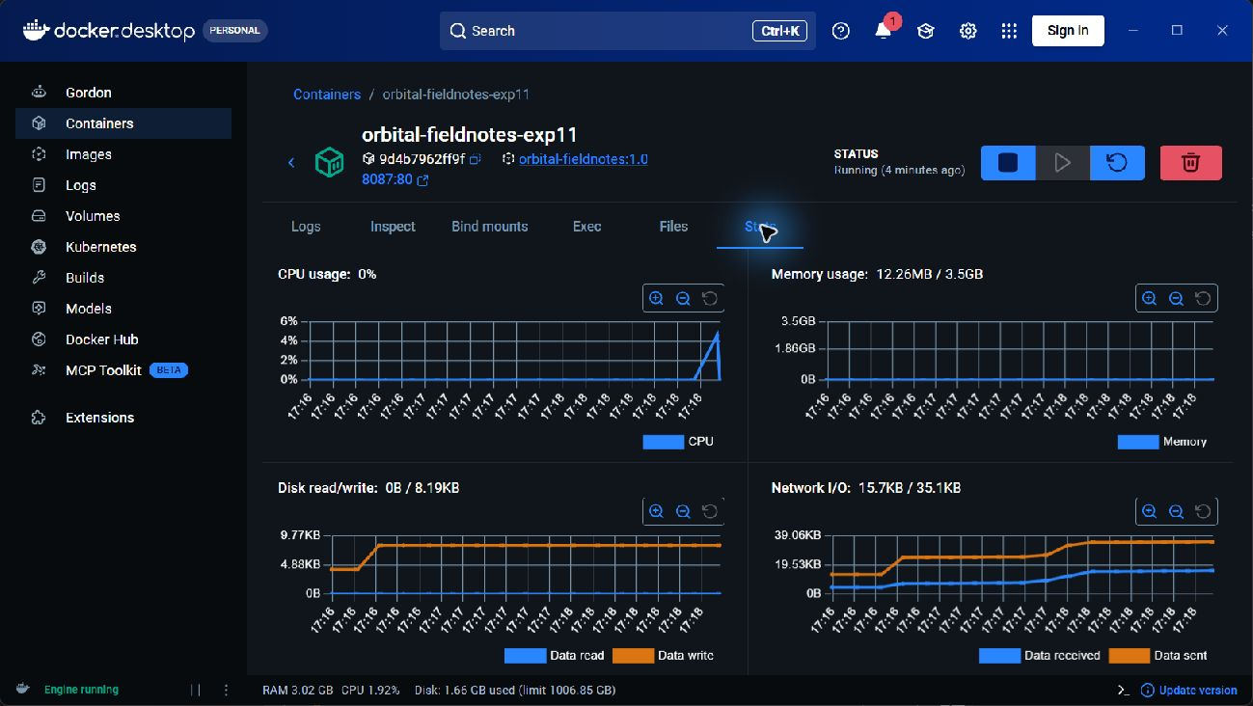
Figure 1 Docker container running after the original Windows prerequisites and engine startup were repaired.
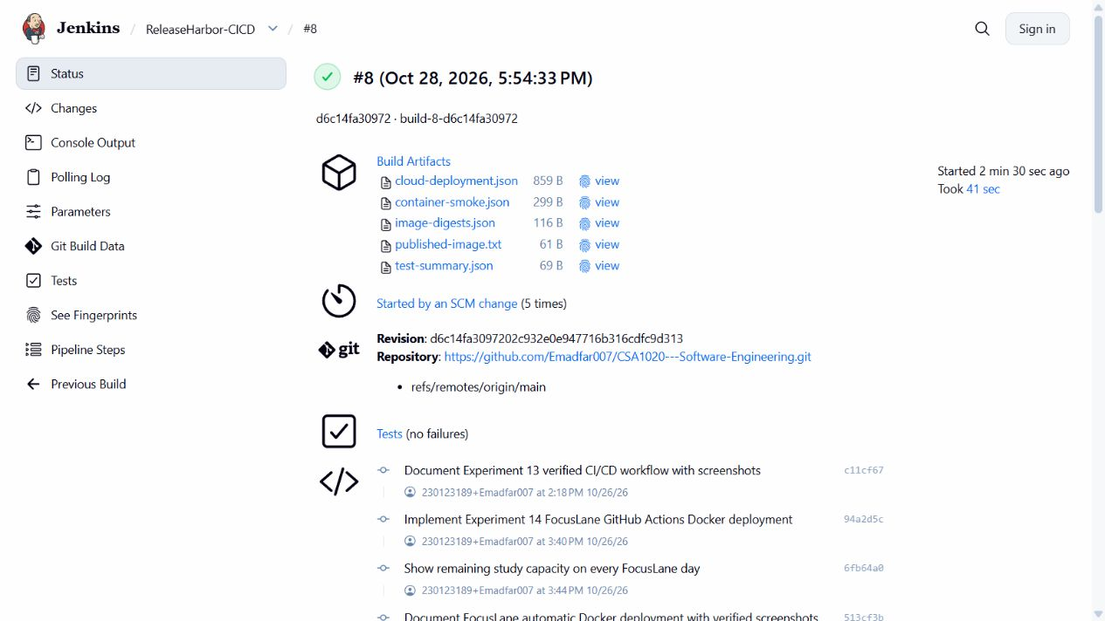
Figure 2 Jenkins build 8 completed actual Docker image delivery to the browser lab on 28 October 2026.

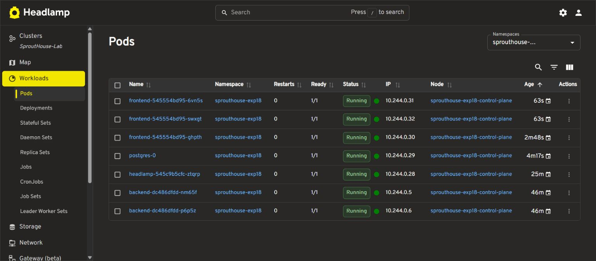
Figure 3 Ready workload view after the Headlamp startup and ephemeral-storage corrections.
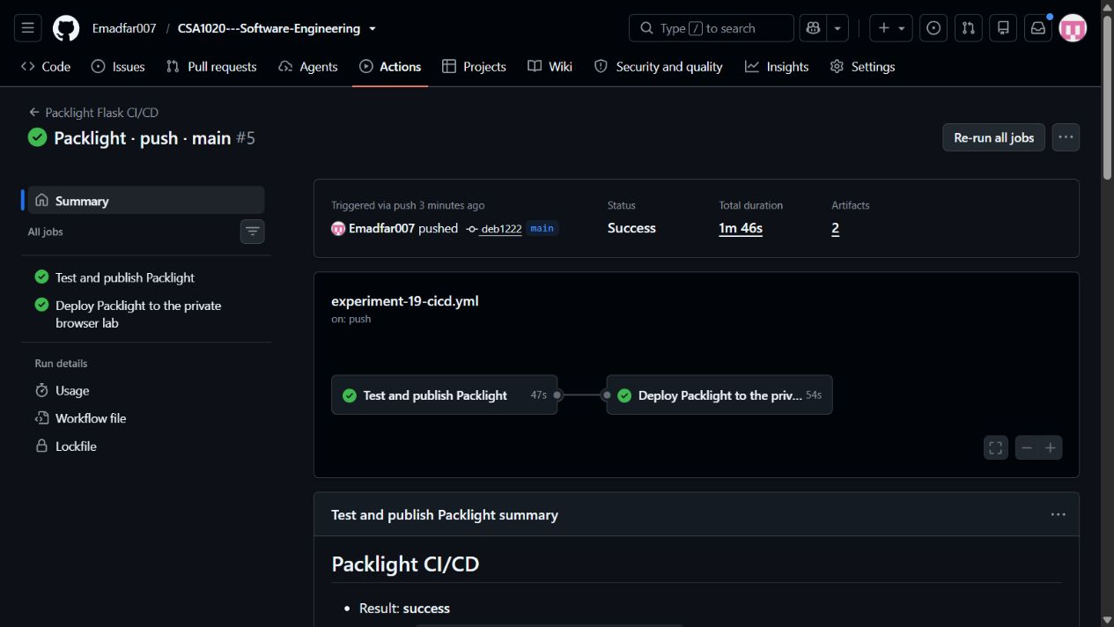
Figure 4 Actions build 5.1 completed container publication and verified browser deployment after the authorization and protocol fixes.

Result
The guide explains the causes and repair procedure for all 20 documented findings from the Docker-based work. Windows prerequisites and launch paths were repaired during the former local setup; health and readiness checks were corrected; cloud startup and database verification were fixed; and container delivery was retargeted and verified after Render quota suspension.
A successful repair is demonstrated by the correct behavior after the change, not just by a command finishing. The original local audit passed 15 of 15 expected HTTP checks. Later browser delivery verified Jenkins build 8 and Actions builds 6.1 and 5.1 against the actual running source and build identity. Storage and uninstall preservation checks also passed.

Confirm a repair before closing the issue
- The original error is no longer present, and Docker can contact the intended Server.
- The affected container is healthy or the Kubernetes workload is Ready, with stable logs.
- A real request succeeds, invalid input is handled correctly and the image or build identity matches the expected release.
- Persistent records and backups remain intact, and the fix survives a relevant restart.
- Any remaining platform limits are recorded. Render quota suspension was worked around by changing target, not removed by a Docker repair.

Current browser repair and verification shortcuts
Run these from the original repository root in Codespaces. Choose one affected profile; cicd runs Experiments 13 14 and 19 together.
bash browser-lab/bin/lab start 12 --kubernetes
bash browser-lab/bin/lab start 16
bash browser-lab/bin/lab start 17
bash browser-lab/bin/lab start 18
# Automatic delivery targets together
bash browser-lab/bin/lab start cicd
bash browser-lab/bin/lab deploy-status
bash browser-lab/bin/lab urls
The private Codespace must be running and within its free monthly allowance. Its recorded budget blocks paid usage; free quotas, a 30-minute idle timeout and 30-day inactive retention still apply. Stop the Codespace after use and preserve private data and deployment keys before deletion or rebuild.
Verified browser deployment and restart evidence
Original experiment reports and detailed evidence

Official troubleshooting references
Microsoft WSL | Docker restart policies
Docker health checks | Docker disk usage
Kubernetes probes | GitHub deployment status
Codespaces quotas | Render Free limits

